# **Manual Test Routine Guide**

## Pedometer with 16x2 LCD – KL25Z

*NOTE: The test routine should be operated in the “Debug” build to check the debug logs on the serial terminal. It would display all the required debug/test messages needed for manual testing.*

### Test Case 1 – Calibration

The board should be placed on a flat surface for calibration. The Calibration results should be printed as displayed below on the serial terminal. If the debug messages match with the below mentioned snapshot, it means the device is accurately calibrated (the avg values may differ a little than the screenshot, but it would handle while calculating the calibrated average value.

If all these lines are not printed on the terminal it would mean the test has failed and the device is not calibrated properly.

Figure 1 Calibration testing screen capture

### Test Case 2 – Check if non-step movements are not detected as steps

* Move the board in the vertical motion. It should not increment the number of steps on the terminal or the LCD Display.

Figure 2 Vertical movement test

* Move the board in the horizontal motion. It should not increment the number of steps on the terminal or the LCD Display.

Figure 3 Horizontal movement test

### LCD Test

Boot the KL25Z board and visually check the display message on the LCD. The message sequence should go as follows:

* Screen 1
  + Line 1: PEDOMETER
  + Line 2: Version 1.0

Figure LCD Screen 1

* Screen 2
  + Line 1: PEDOMETER
  + Line 2: Counting Steps..

Figure LCD Screen 2

* Screen 3
  + Line 1: STEPS: <Step Count>
  + Line 2: Counting Steps…

Figure LCD Screen 3

If all these 3 screens are accurately displayed without any garbage value, it would pass this test case.

### Pedometer Test

The device should be tilted on either side (i.e. left or right) and should be swayed slowly to emulate a step taken. On each sway the LCD and the terminal should display the corresponding number of steps.

Figure 7 Pedometer terminal display test

Check if the accurate number of steps are detected by the pedometer device.

This test should also include border line testing mentioned below:

* Move the board in vertical motion, it should not increment steps.
* Move the board in horizontal motion, it should not increment steps.

Check the videos for better clarity.

Displays the number of steps taken corresponding to the motion of the sensor (development board).

Note the position of the board to check the count. This position emulates device’s position when a person’s walking.

Figure Pedometer Test with Board Orientation

### Pedometer Reset Test – TSI Sensor

After capturing some step counts on the device **touch the TSI sensor** to reset the device.

Test if it resets the pedometer algorithm and the step count.

* The terminal should display “Pedometer Reseted by TSI Touch” and the step count should be printed as "STEPS: 0” on the very next print.

Figure 9 TSI reset test

* The LCD should print 2 screens:
  + Screen 1
    - Line 1: STEPS: 0
    - Line 2: RESET

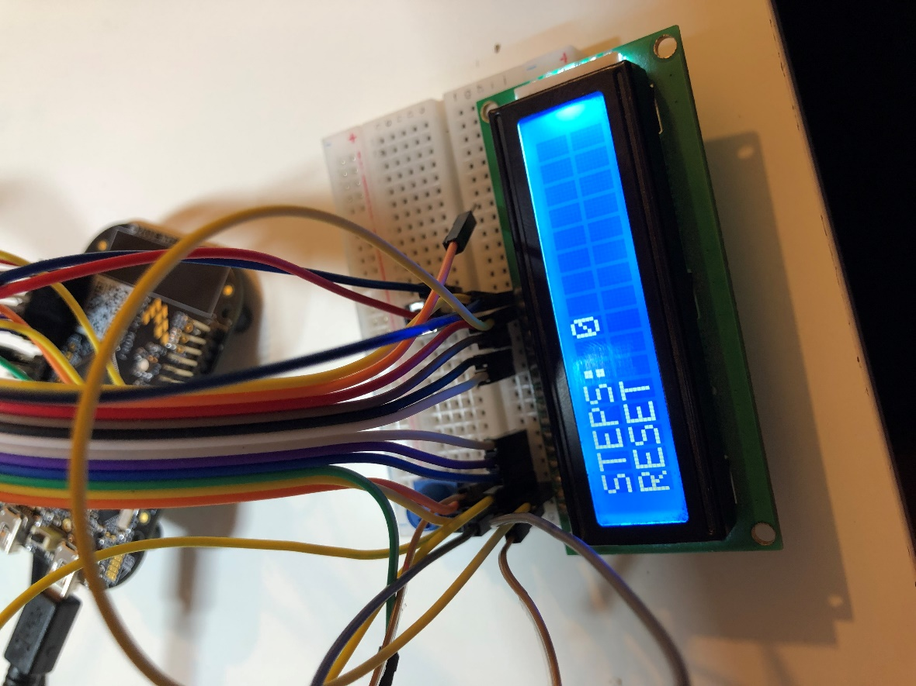

Figure Reset LCD Screen on TSI interrupt

* + Screen 2 (After Reset)
    - Line 1: STEPS: <Step Count>
    - Line 2: Counting Steps..

Figure Steps on pedometer being reset

### Pedometer Reset Test – External Button

After capturing some step counts on the device **press the push button** to reset the device.

Test if it resets the pedometer algorithm and the step count.

* The terminal should display “Pedometer Reseted by Push Button” and the step count should be printed as "STEPS: 0” on the very next print.

<Insert the terminal SS for reset>

* The LCD should print 2 screens:
  + Screen 1
    - Line 1: STEPS: 0
    - Line 2: RESET



Figure Reset LCD Screen on Push Button interrupt

* + Screen 2 (After Reset)
    - Line 1: STEPS: <Step Count>
    - Line 2: Counting Steps...

Figure Steps on pedometer being reset